Regulations:
A17

H.T No

Sreenidhi Institute of Science and Technology
(An Autonomous Institution)
Code No: 6A304 Date: 13-Dec-2018 (FN)

B.Tech II-Year I-Semester End External Examination, Nov/Dec - 2018 (Regular)
Circuits and Networks-II (EEE)

Time: 3 Hours Max.Marks:75

Note: a) No additional answer sheets will be provided.
b) All sub-parts of a question must be answered at one place only, otherwise it will not be valued.
c) Missing data can be assumed suitably.

Part - A Max.Marks:25

Answer all QUESTIONS.

1. | A balanced star-connected load of (8+j6)Ω per phase is connected to a balanced 3-phase 400V supply, find the line current and power factor. | [3M]
2. | Define and write the Time constant for RL series and RC series circuits. | [3M]
3. | What is transfer function? Write a short note on significance of poles and zeros. | [3M]
4. | Write the Y-parameters in terms of Z-parameters. | [3M]
5. | State classification of filters and define the characteristic impedance. | [3M]
6. | Define Line Spectra and phase angel spectra. | [2M]
7. | Define Active Power, Reactive power and power factor. | [2M]
8. | Write the condition for reciprocity and symmetry for ABCD parameters. | [2M]
9. | Explain the condition for even function symmetry. | [2M]
10. | List the advantages of three phase systems over a single phase system. | [2M]
Part – B Max.Marks:50
ANSWER ANY FIVE QUESTIONS. EACH QUESTION CARRIES 10 MARKS.

11. | a) | Three similar coils, each having a resistance of 20Ω and an inductance of 0.05H are connected in star to a 3-phase, 50Hz supply with 400V between lines. Calculate the total power absorbed and line current. Draw the neat circuit diagram and phasor diagram of current and voltages. | [5M]
 | b) | Explain the measurement of 3-phase power by two wattmeter method with neat circuit diagram. | [5M]
12. | a) | The circuit shown below consisting of series RLC elements with R=10Ω. L=0.5H and C=200µF has a sinusoidal voltage If the switch is closed when . Determine the current equation.  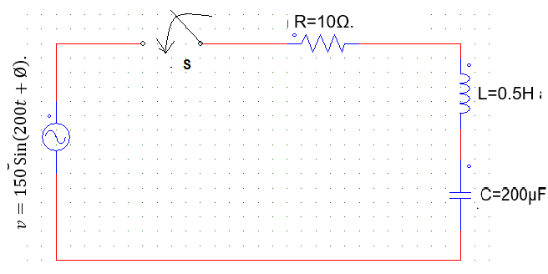 | [5M]
 | b) | A 20Ω resistor, a 0.01H inductor and a 100µF capacitor are connected in series. A D.C voltage of 100V is suddenly applied to the circuit. Obtain the equation showing how the current through the circuit varies with the time. Find the maximum current and the time at which it occurs. | [5M]
13. | a) | Explain the properties and necessary conditions for transfer functions. | [5M]
 | b) | Obtain the transform impedance of the network shown below.  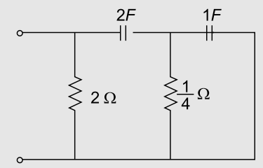 | [5M]
14. | a) | Obtain the admittance parameters of the circuit shown below.  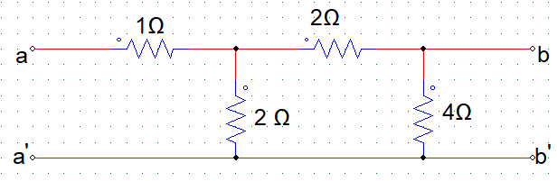 | [5M]
 | b) | Find the transmission parameters for the two-port network shown below.  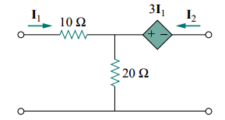 | [5M]
15. | a) | Design m-derived Low Pass filter having cut-off frequency of 1Khz, design impedance of 400Ω and resonant frequency is 1100Hz. | [5M]
 | b) | Design a filter section which is required to pass all the frequencies above 25KHz and to have a nominal impedance of 600Ω. Design  (i) a high pass T-Section filter and  (ii) a high pass π- section filter to meet these requirements. | [5M]
16. | a) | Explain the properties of Fourier transforms. | [5M]
 | b) | Find the Fourier series of the periodic function v(t) shown below circuit.  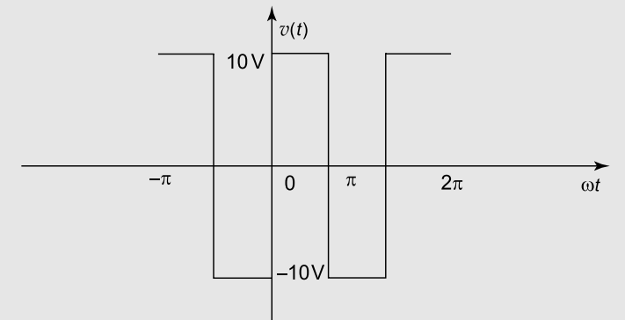 | [5M]
17. | a) | Derive the relationship between the line current and phase currents and voltages in a delta connection. | [3M]
 | b) | In a series RL circuit, R=5Ω, L=1H. A DC voltage of 20V is applied at t=0. Obtain i(t). | [4M]
 | c) | What are the necessary conditions for driving point function? | [3M]
18. | a) | For a two-port network 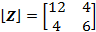. Find if the network is terminated with a 2Ω resistor. | [3M]
 | b) | Design low pass filter of T-type with characteristic impedance at zero frequency of 600Ω and cut-off frequency at 5 MHz | [4M]
 | c) | Determine the Fourier transform of a signal shown below.  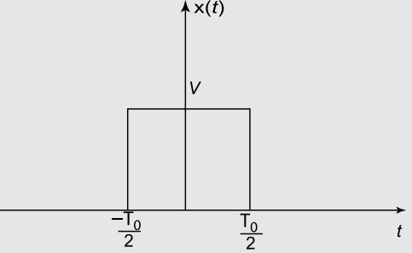 | [3M]

-- 00 -- 00 –

